|  |
| --- |
| cid:image001.gif@01C91A3C.7529E690 |
| Litle & Co. Integration |
|  |
|  |
| **2/18/2010** |

|  |
| --- |
| Describes the Litle & Co. integration components and Site Genesis implementation |

Contents

1 Overview 4

2 Features Implemented 5

2.1 Credit Card Payment Processing 5

3 Integration Components 6

3.1 Components 6

3.1.1 Credit Cart Payment 6

3.1.2 Credentials 6

3.2 Demandware Business Manager 7

4 Demandware SiteGenesis Reference Application Implementation 8

5 Appendix 9

5.1 Setting Litle development Environment 9

5.2 Business Manager settings 9

**Intended Audience**

This document is intended for technical personnel who will be setting up and integrating Litle’s Credit Card Payment Processing with the Demandware SiteGenesis Storefront.

**Revision History**

| Date | Description | Author |
| --- | --- | --- |
| 03/24/2010 | Version 1.0 | Demandware |

# Overview

This document describes the components of the Litle Integration and SiteGenesis implementation.

External Documents

* Litle_Online_Processing_Guide_XML7.2_V2.4.pdf

This reference implementation takes in to account the list of features defined in the section below, it may not cover application or client specific requirements. If the core implementation scripts needs to be updated please raise a ticket with Demandware at <https://demandware.helpstream.biz/> .

# Features Implemented

Following are the list of features implemented in Litle & Co. integration.

## Credit Card Payment Processing

Credit card payment processing allows customers to enter their credit card information for purchasing products on the Storefront. Litle’s credit card processing services provide the functionality to integrate credit card payment processing through Litle services.

# Integration Components

## Components

Litle integration has the following main cartridge.

* int_litle_payment – This cartridge has pipelines web services definition files and scripts. The files can be changed to suit the application or client’s requirements.

### Credit Card Payment

This call is made to get an initial auth on the order total. Following values are passed on the web service call to Litle.

* Name on the Credit Card
* Credit Card Type
* Credit Card Number
* Credit Card Expiration Date
* Credit Card CVN
* Billing Address (Street, city, state, zipcode)
* Order Total
* IP Address of the customer

Litle response contains the following information.

* Response Code
* Litle Transaction ID
* Auth Code
* AVS Code
* CCV Code

### Credentials

For setting up the Litle cartridge the following information is required.

* Demandware IP Address (for Litle to accept requests)
* Merchant Id
* API Username
* API Password

## Demandware Business Manager Metadata Import

To setup the Litle integration configuration in Demandware Business Manager, go to Administration > Site Development > Site Import & Export (BETA), then upload and import the meta_data_litle.zip to set up the attributes below:

* Following attributes will be added (by the meta data) to System object “PaymentTransaction” under *Administration > Site Development > System Objects*.
  + litleTransactionID (String)
  + litleAuthCode (String)
  + litleResponseCode (String)
  + litleResponseMessage (String)
  + litleAVSCode (String)
  + litleCCVCode (String)
* Litle specific attributes – Add the following attributes to Site Preferences under Administration > System Objects (see the image in appendix)
  + LitleMerchantID_CC (String)
  + LitleURL (String)
  + LitleUsername (String)
  + LitlePassword (String)
  + LitleReportGroup (String)

# Demandware SiteGenesis Reference Application Implementation

Update COPlaceOrder-AuthorizeCreditCard pipeline as shown in the diagram below.

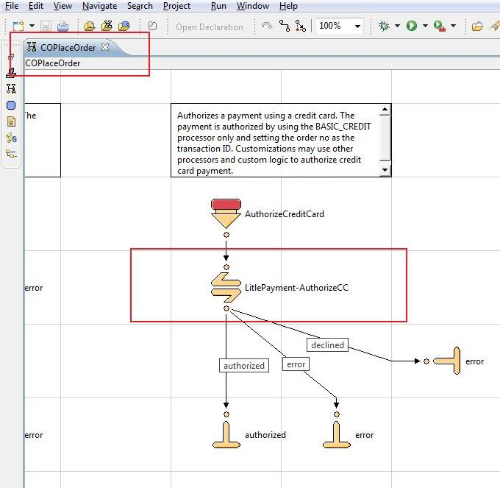

# Appendix

## Setting Litle development Environment

Inform Litle of the outgoing IP address of your Demandware POD, and any “cloudbox” development sandboxes, so that Litle can enable accepting web services requests from those IP addresses.

* For standard POD-based Demandware realms, provide the outgoing IP address of the POD. Each pod has a hostname for its outgoing IP address, in the form outgoing.pod*n*.demandware.net. For example, the hostname for the outgoing IP address for POD8 is outgoing.pod8.demandware.net.
* For “cloudbox” sandbox instances, the IP address of the Business Manager hostname is also the outbound IP address. You must provide Litle the IP address of every cloudbox on which you are testing Litle services.

To find the IP address of a hostname, use a command-line utility like ping or dig, or a web-based service like <http://whatismyip.com/>.

## Business Manager Settings

### Site Cartridge Path

After you’ve imported the int_litle_payment cartridge into your workspace and uploaded it to your Demandware insteance, you must add int_litle_payment to the cartridge search path for each site that will use Litle payment processing services.

In Business Manager, go to Administration > Sites > Manage Sites, select your site, and click the Settings tab to view the cartridge search path. Add int_litle_payment to the end of the search path, separated with a colon. For example, if the cartridge search path is:

app_storefront_example

then this step changes it to:

app_storefront_example:int_litle_payment

### Payment Processor

In Business Manager, go to Site > Ordering > Payment Processors, then press the New button to create a new payment processor with the ID set to LITLE_CREDIT.

The following image shows the form for creating the new payment processor:

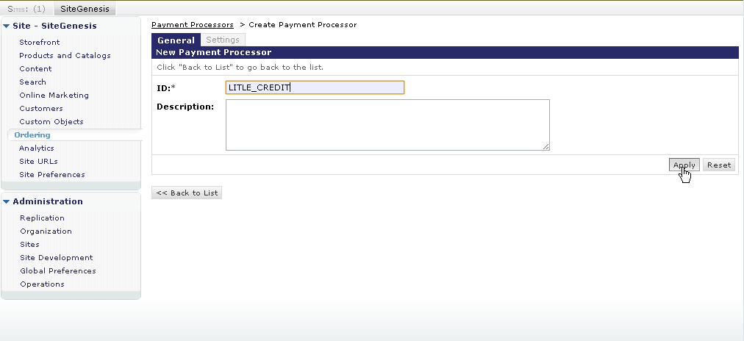

You must complete this step for each site that will be using Litle payment authorization services.

When complete, the LITLE_CREDIT payment processor appears in the list of payment processors for the site, as shown in the following image:

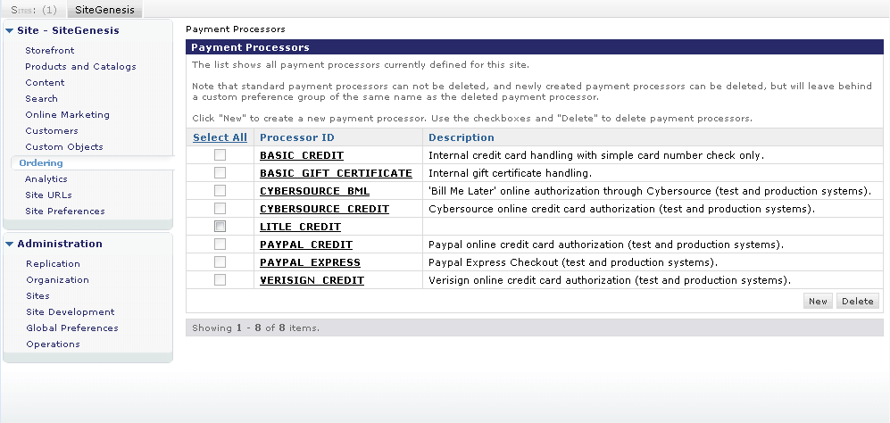

### Site Preferences

In Business Manager, go to Site > Site Preferences > Custom Preferences to set site preferences in support of Litle services. The following image shows the custom site preferences settings in the Demandware Business manager:

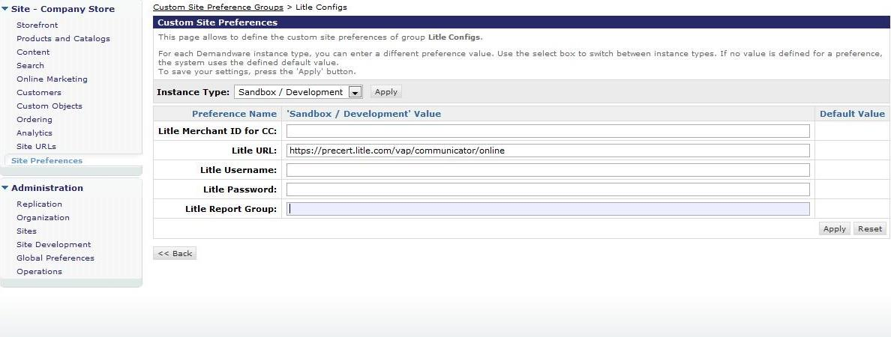

Use the “Instance Type” dropdown menu and press Apply to set preferences for each instance type.

* Litle Development URL – <https://precert.litle.com/vap/communicator/online>
* Litle Production URL – <https://payments.litle.com/vap/communicator/online>

You must complete this step for each site that will be using Litle payment authorization services.